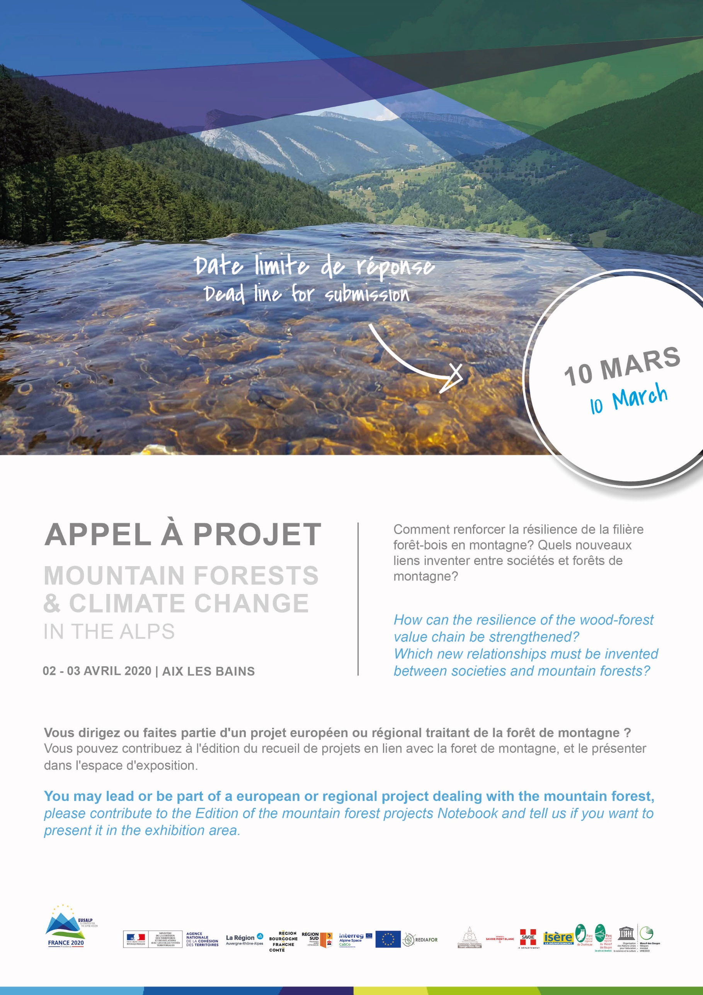
Call for Projects

Draft Registration Form

« Mountain Forests & Climate Change in the Alps » is a European event organized by the Regional Union of Forest Communes Auvergne-Rhône-Alpes within the framework of the EUSALP French Presidency 2020. This event focuses on the multifunctionality of mountain forests in the context of climate change.
Its objective is to collect technical and political recommendations in favor of mountain forests for the next European programming period 2021-2027. How? Thanks to European cooperation projects, regional approaches, etc.

You can :
- contribute to the edition of the mountain-forest projects compilation book that will be distributed to participants
- apply to present this project on the exhibitor space.

Project acronym
Project name
Lead Partner (organization)
Contact person
Project description
(Between 800 and 1200 characters maximum, including spaces)

Attachments: Project logo and visuals presentation (photo, illustration, map, diagram, etc.) free of rights/no copyright

I would like to present this project on a stand on April 02: YES NO
(bring 1 roll up, brochures, … assembly and disassembly the same day)

Please return this form and the attachments by email to: marianne.delaporte@communesforestieres.org

Return deadline is the 10th of March

